**Personal Expense Tracker Application**

**PNT2022TMID48482**

TEAM LEAD (SURYA P)

TEAM MEMBER_1 (KARTHIKEYAN.J)

TEAM MEMBER_2 (PRABAKARAN.A)

TEAM MEMBER_3 (VASANTH.R)

TEAM MEMBER_4 (ANAND.T)

**Project Report**

|  |  |
| --- | --- |
| **Team ID** | **PNT2022TMID48482** |
| **ProjectTitle** | **Personal Expense Tracker Application** |

**1.INTRODUCTION**

**1.1Project Overview:**

Mobile devices and applications are known to bring crucial additional benefits in terms of usability for users which include accessibility, portability and location awareness. As what most technology-literate would, an application with a specified use of their daily life would be necessarily installed for the full extent of convenience. Similarly, to other applications, an income tracking application would bring more benefit when it comes to improving the lifestyle of users.

“Expense Tracker Application” is introduced as an application, beneficial for users to handle their expense on a daily when they are reminded of it. It comes in handy when users have trouble being consistent in tracking their expenses, especially when they forget to note their expenses. In this application, users can identify expenses such as food bills, taxation, phone bills and electricity bills. By inserting the bills into the application, users can balance out their income and usage with the automated feature so that users do not have to calculate on their own and end up miscalculating. Tracking expenses when done for personal matters, helps users to exercise organizing receipts and outline their cash flows for budget drafting Thereafter, the least square method is used to find the best prediction of monthly budget.

**1.2 Purpose:**

Personal Expense Tracker Application helps you keep track of balance, outlook, cash-flow, spending, credit, budget, goals, planned payments, debts, shopping lists, warranties, loyalty cards, and currency rates. Also known as expense manager and money manager, an expense tracker is a software or application that helps to keep an accurate record of your money inflow and outflow. Many people in India live on a fixed income, and they find that towards the end of the month they don't have sufficient money to meet their needs.Today, there are several expense manager applications in the market. Some are paid managers while others are free. Even banks also like offer their customer expense tracker to help them out. Before you decide to go in for a money manager, it is important to decide the type you want.If you are looking for something simple, you need to stay away from complex applications that have a steep learning curve. You will get frustrated and not use the tracker. On the other hand, if you are looking for a feature-laden application that handles all your expenses and finances seamlessly, going in for a simple app will be useless, as it will not have the features you are looking for.

**2.LITERATURE SURVEY:**

**2.1 Existing problem:**

Keeping track of expenses these days is not an easy job for people with busy lifestyle, making sure each and every purchase is jotted is already a hassle but making sure the right outcome of savings after being deducted with expenses is even harder. Therefore, an easy solution for these issues is to find the right medium for users to maintain a better expense tracking diary. This mobile application is proposed to help users overcome the struggles they have to endure when they do not track their expenses or track their expenses manually or even have troubles with the current existing expense tracker that they are using. The common issue that occurs when users track their expenses manually are that, they tend to overspend and users will not know where their money go which will consequently interfere with their future plans. But the problems with the existing applications are the fact that some are not user friendly, outdated and does not solves the users’ difficulties in planning their budget.

**2.2 References:**

**PAPER 1**

**TITLE:** Barcode Recognition System

**AUTHOR NAME:** Saad & Hashim

**PUBLICATION YEAR:**2013

**DESCRIPTION:**

Barcode became essential elements in sales and products services due to importance of keeping records of all items in place. For this purpose, there are many methods implemented to make the barcode reading process became easier to users. This survey deals to develop a barcode recognition system by using image processing. The system will be able to read barcode through an image and the system capable to capture the image by using a webcam.

**PAPER 2**

**TITLE:** Barcode Scanning in Android Applications

**AUTHOR NAME:** J. Vidhya and K. John Singh

**PUBLICATION YEAR:** 2015

**DESCRIPTION:**

The convenience of imaging phones affords people the mobile raised area for interpreting barcode rather than the usage of the conservative scanner which leads to lack of mobility. Though, the short-reserve capture of barcodes through an imaging phone

**PAPER 3**

**TITLE:** Budget Estimator Android Application

**AUTHOR NAME:** NamitaJagtap, Priyanka Joshi, Aditya Kamble

**PUBLICATION YEAR:** 2019

**DESCRIPTION:**

This application takes income from user and divides in daily expense allowed, if user exceeds that days expense it will cut if from your income and give new daily expense allowed amount, and if that days expense is less it will add it in savings. Expense tracking application will generate report at the end of month to show income-expense via multiple graphs.

**PAPER 4**

**TITLE:** Expense Tracker : A Smart Approach to Track Everyday Expense

**AUTHOR NAME:**Ms. J. AngelinBlessy, Anant Prakash Singh, Navneet Kumar, Hrithik Gupta

**PUBLICATION YEAR:** 2020

**DESCRIPTION:**

Expense Tracker is a day-to-day expense management system designed to easily and efficiently track the daily expenses through a computerized system that eliminates the need for manual paper tasks that systematically maintains records and easily accesses data stored by the user.

**PAPER 5**

**TITLE:** Voice Controlled Web Application

**AUTHOR NAME:** Raj Gandhi, Romil Desai, Marmik Modi, Dr.SuvarnaPansambal

**PUBLICATION YEAR:** 2022

**DESCRIPTION:**

Voice or speech recognition systems allow a user to make a hands-free request to the computer, which in turn processes the request and serves the user with appropriate responses. A voice-controlled system embedded in a web application can enhance user experience and can provide voice as a means to control the functionality.

**2.3 Problem Statement Definition:**

|  |  |  |  |  |  |
| --- | --- | --- | --- | --- | --- |
| **Problem Statement (PS)** | **I am (Customer)** | **I’m trying to** | **But** | **Because** | **Which makes me feel** |
| PS-1 | An Employee | Make a monthly budget. | There are no facilities to set a budget. | I need to save money for my future plane | Frustrated |
| PS-2 | A Manager | Keep track of my expenses. | Can’t categorize  the  various  types of expenses | There is no option to organize the various expenses | Uncomfortable |

**Customer Problem Statement:**

A well-articulated customer problem statement allows us to find the ideal solution for the challenges our customers face. Throughout the process, you’ll also be able to empathize with your customers, which helps you better understand how they perceive your products and services.

**3.IDEATION & PROPOSED SOLUTION**

**3.1 Empathy Map Canvas**

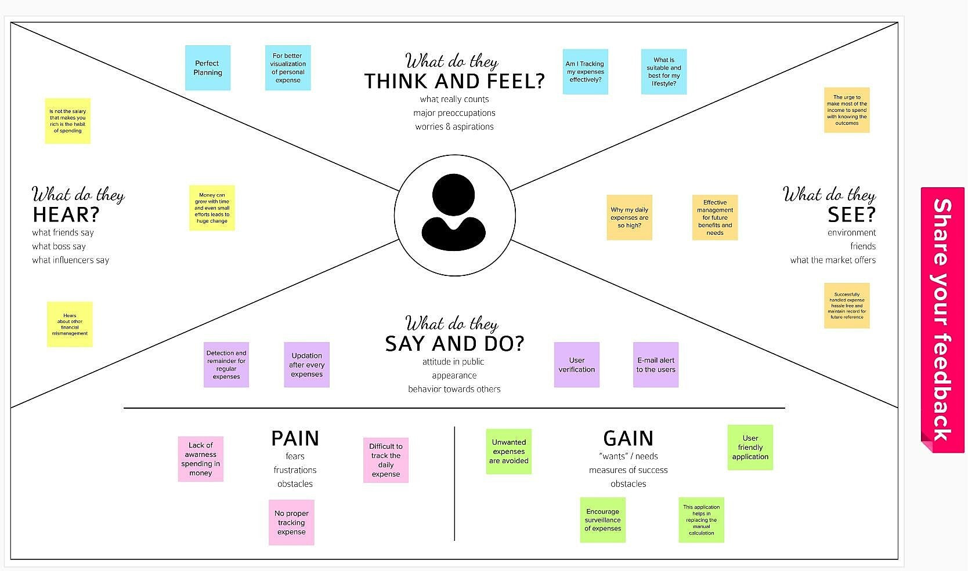

**3.2 Ideation & Brainstorming**

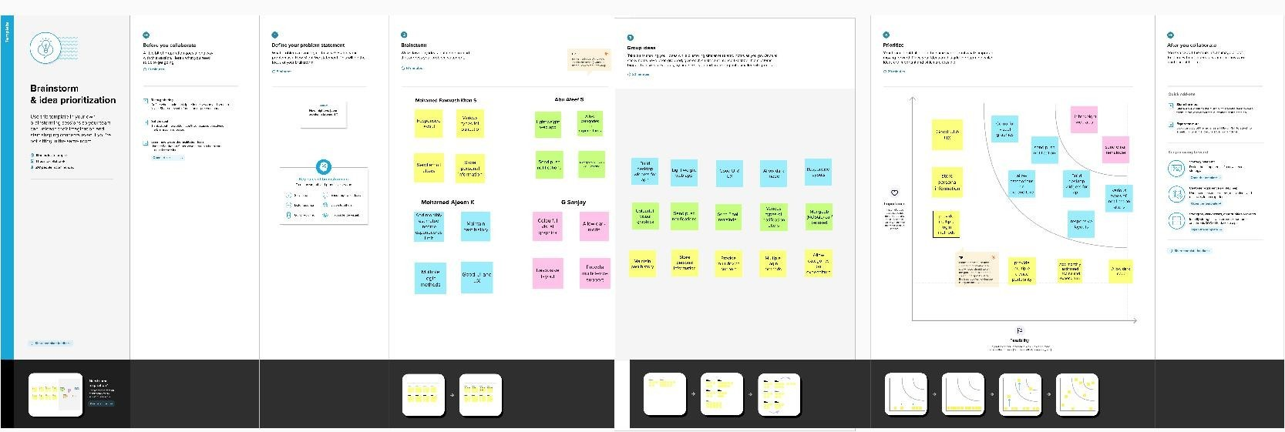

**3.3 Proposed Solution**

|  |  |  |
| --- | --- | --- |
| **S.No** | **Parameter** | **Description** |
| 1. | Problem Statement(Problem to be solved) | 1. There a lot of budget fixing software that are available online but some of these software fall short in helping users to actually create and stick to a budget. 2. One of the drawbacks is the on-going maintenance, all users financial accounts and consolidating their activity into one dashboard. 3. . However though, some of this existing software mostly has complicated features that are not user friendly. |
| 2. | Idea/Solution description | 1. Due to the busy and hectic lifestyle people tend to overlook their budget and end up spending an excessive amount of money since they usually didn’t plan their budget wisely. 2. User cannot predict future expenses. 3. While they can write down their expenses in a excel spreadsheet, their lack of knowledge in managing finances will be a problem |
| 3. | Novelty/Uniqueness | 1. This application tracks your every expenses anywhere and anytime without using the paper work. 2. Just click and enter your expenditure. |
| 4. | Social Impact/Customer Satisfaction | 1. People can experience a clean atmosphere. 2. If your expense exceeded than specified limit, the application will show you an alert message in form of a pie chart. |
| 5. | Business Model(Revenue Model) | 1. Business people can use subscription/premium feature of this application to gain revenue. |
| 6. | Scalability of the Solution | 1. IBM cloud will automatically allocate the storage for the users. |

**3.4 Problem Solution fit**

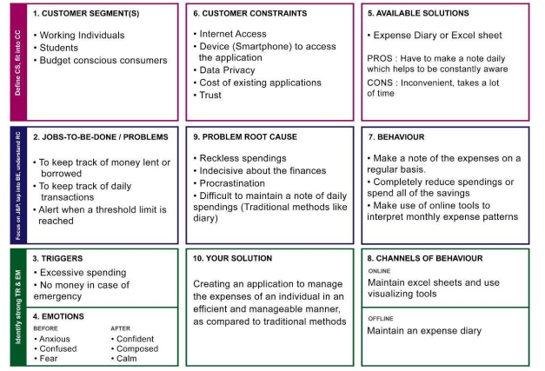

**4.REQUIREMENT ANALYSIS**

**4.1Functional requirement**

**Followingarethefunctionalrequirementsoftheproposedsolution.**

|  |  |  |
| --- | --- | --- |
| **FRNo.** | **FunctionalRequirement(Epic)** | **SubRequirement(Story/Sub-Task)** |
| FR-1 | User Registration | Registration is done through email. |
| FR-2 | User Confirmation | Confirmation via Email. |
| FR-3 | User Login | By entering username and password. |
| FR-4 | Enter your expenses page. | Collects user’s expenses data with date and time included. |
| FR-5 | Expenses Report is generated. | Represent all user’s data in the form of a graphical and easy to understand report. |
| FR-6 | Option to add categories and type of expense to the data | The app can organize expenses based on different categories. |

**4.2 Non-Functional requirements:**

**Following are the non-functional requirements of the proposed solution.**

|  |  |  |
| --- | --- | --- |
| **FRNo.** | **Non-FunctionalRequirement** | **Description** |
| NFR-1 | **Usability** | Provides an effective and user-friendly way to keep track of all the users expenses. |
| NFR-2 | **Security** | Data is protected by giving a unique login ID and password. Also, by not sharing users’ data with  third parties. |
| NFR-3 | **Reliability** | Since the app is hosted on the web it can be accessed anytime and from anywhere on all devices if you have a device with internet connectivity. |
| NFR-4 | **Performance** | User data is stored in a very data efficient way,  which reduces load time of the application. |
| NFR-5 | **Availability** | Application is hosted on the web and should be available 24/7 for the user. |
| NFR-6 | **Scalability** | Can be scaled by increasing database size and better UI design to suit a larger audience. |

**5.PROJECT DESIGN**

**5.1Data Flow Diagrams**

A Data Flow Diagram (DFD) is a traditional visual representation of the information flows within a system. A neat and clear DFD can depict the right amount of the system requirement graphically. It shows how data enters and leaves the system, what changes the information, and where data is store.

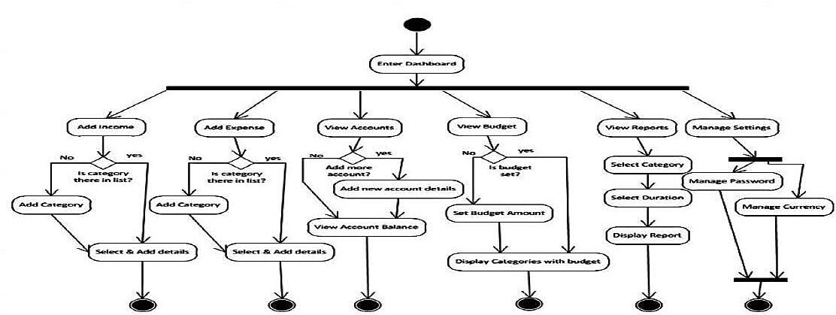

**5.2Solution & Technical Architecture:**

Solution architecture is a complex process–with many sub-processes that bridgesthegapbetween business problems and technology solutions. Its goals are to: Find the best tech solution to solve existing business problems.

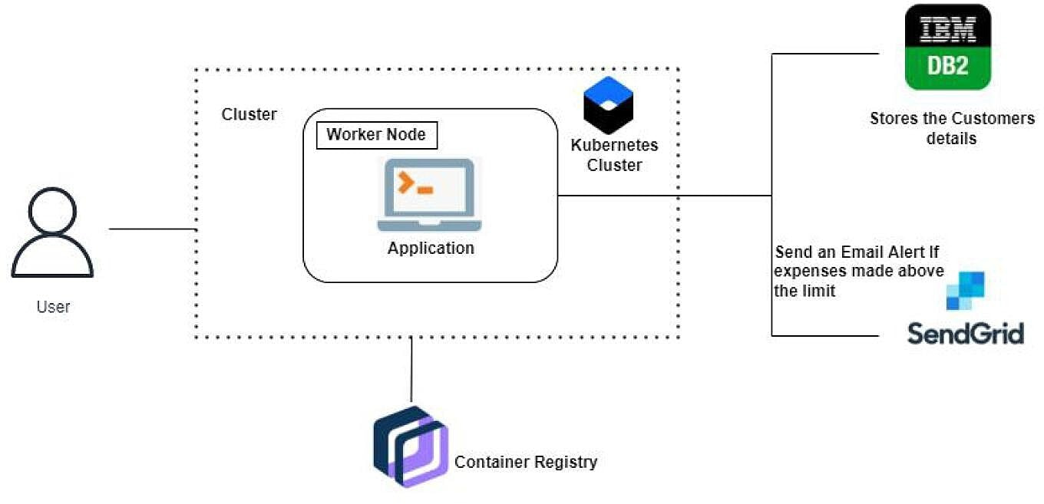**Table-1:Components & Technologies:**

|  |  |  |  |
| --- | --- | --- | --- |
| **S.no** | **Component** | **Description** | **Technology** |
| 1. | User Interface | MobileApplication | HTML, CSS, JavaScript. |
| 2. | Application Logic | Logic for a process in the application | Javascript |
| 3. | Database | DataType,Configurations etc. | IBM cloud |
| 4. | CloudDatabase | Database Service on Cloud | IBMCloud |
| 5. | FileStorage | File storage requirements | Local File system and IBM cloud |
| 6. | Infrastructure(Server/Cloud) | Application DeploymentonCloudlocalServerConfiguration | Local and Cloud Foundry |

**Table-2:Application Characteristics:**

|  |  |  |  |
| --- | --- | --- | --- |
| **S.no** | **Characteristics** | **Description** | **Technology** |
| 1. | Open-Source Frame works | GitHub | Internet hosting service |
| 2. | Security Implementations | Application security: Vera-code. | Network automation |
| 3. | Scalable Architecture | It provides the room for expansion more database of smart bins added additionally can be updated. | Cloud storage |
| 4. | Availability | As the system control is connected to web server it is available 24*7 and can be accessed whenever needed. | Server, Appleixe, rep-le |
| 5. | Performance | Performance is high it uses 5mb caches | WirelessSensorNetwork |

**5.3 UserStories**

Use the below template to list all the userstories for the product.

|  |  |  |  |  |  |  |
| --- | --- | --- | --- | --- | --- | --- |
| **User Type** | **Functional Requirement**  **(Epic)** | **User Story**  **Number** | **User Story/Task** | **Acceptance**  **criteria** | **Priority** | **Release** |
| Customer | Registration | USN-1 | As a user, I can register for the application by entering my email,password,and confirming  my password. | I can access my account /dashboard | High | Sprint-1 |
|  |  | USN-2 | As a user, I will receive confirmation email  once I have registered for the application | I can receive confirmation email & click confirm | High | Sprint-1 |
|  | Login | USN-3 | As a user, Ican register for the application through Facebook | I can register& access the dashboard with Facebook Login | Low | Sprint-2 |
|  | Dashboard | USN-4 | As a user, Ican register for the application  through Gmail | I can view my daily expenses | Medium | Sprint-1 |
|  | Category Selection | USN-5 | As a user, I can log into the application by entering email&  password | The mail id and password should be the same. | High | Sprint-1 |
|  |  | USN-6 | As a user I can enter my in come,  expenditure details | I can view my daily expenses. | High |  |
| CustomerCare Executive |  | USN-7 | As a customer executive,  I can solve the log  in issue and other issues of application | I can provide support or solution at anytime. | High |  |
| Administrator |  | USN-8 | As an Administrator I can upgrade or update  the application | I can fix the bug which arises for the customers and users of the  application. | Medium |  |

**6. PROJECT PLANNING & SCHEDULING**

**6.1 Sprint Planning & Estimation**

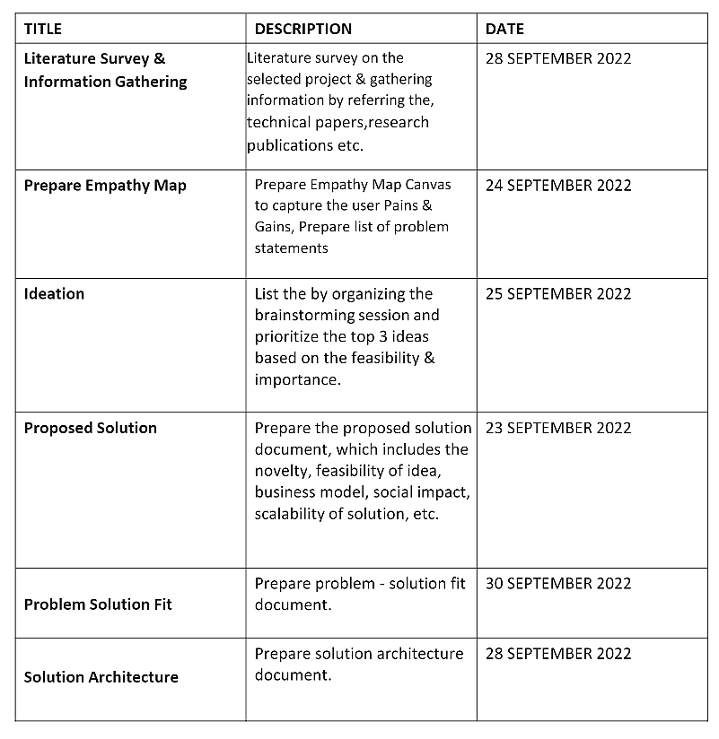

**6.2. Sprint Delivery Schedule**

|  |  |  |  |  |  |  |
| --- | --- | --- | --- | --- | --- | --- |
| Sprint | Total StoryPoints | Duration | Sprint StartDate | Sprint End Date (Planned) | Story Points Completed (as on Planned End Date) | Sprint Release Date (Actual) |
| Sprint-1 | 20 | 6 Days | 23 Oct 2022 | 28 Oct 2022 | 20 | 29 Oct 2022 |
| Sprint-2 | 20 | 6 Days | 30 Oct 2022 | 04 Nov 2022 | 20 | 05 Nov 2022 |
| Sprint-3 | 20 | 6 Days | 06 Nov 2022 | 11 Nov 2022 | 20 | 12 Nov 2022 |
| Sprint-4 | 20 | 6 Days | 13 Nov 2022 | 18 Nov 2022 | 20 | 19 Nov 2022 |

Velocity We have a 6-day sprint duration, and the velocity of the team is 20 (points per sprint). Calculating the team’s average velocity (AV) per iteration unit (story points per day)

AV = sprint duration/velocity =20/6=3.33

**7.CODING & SOLUTIONING (Explain the features added in the project along with code)**

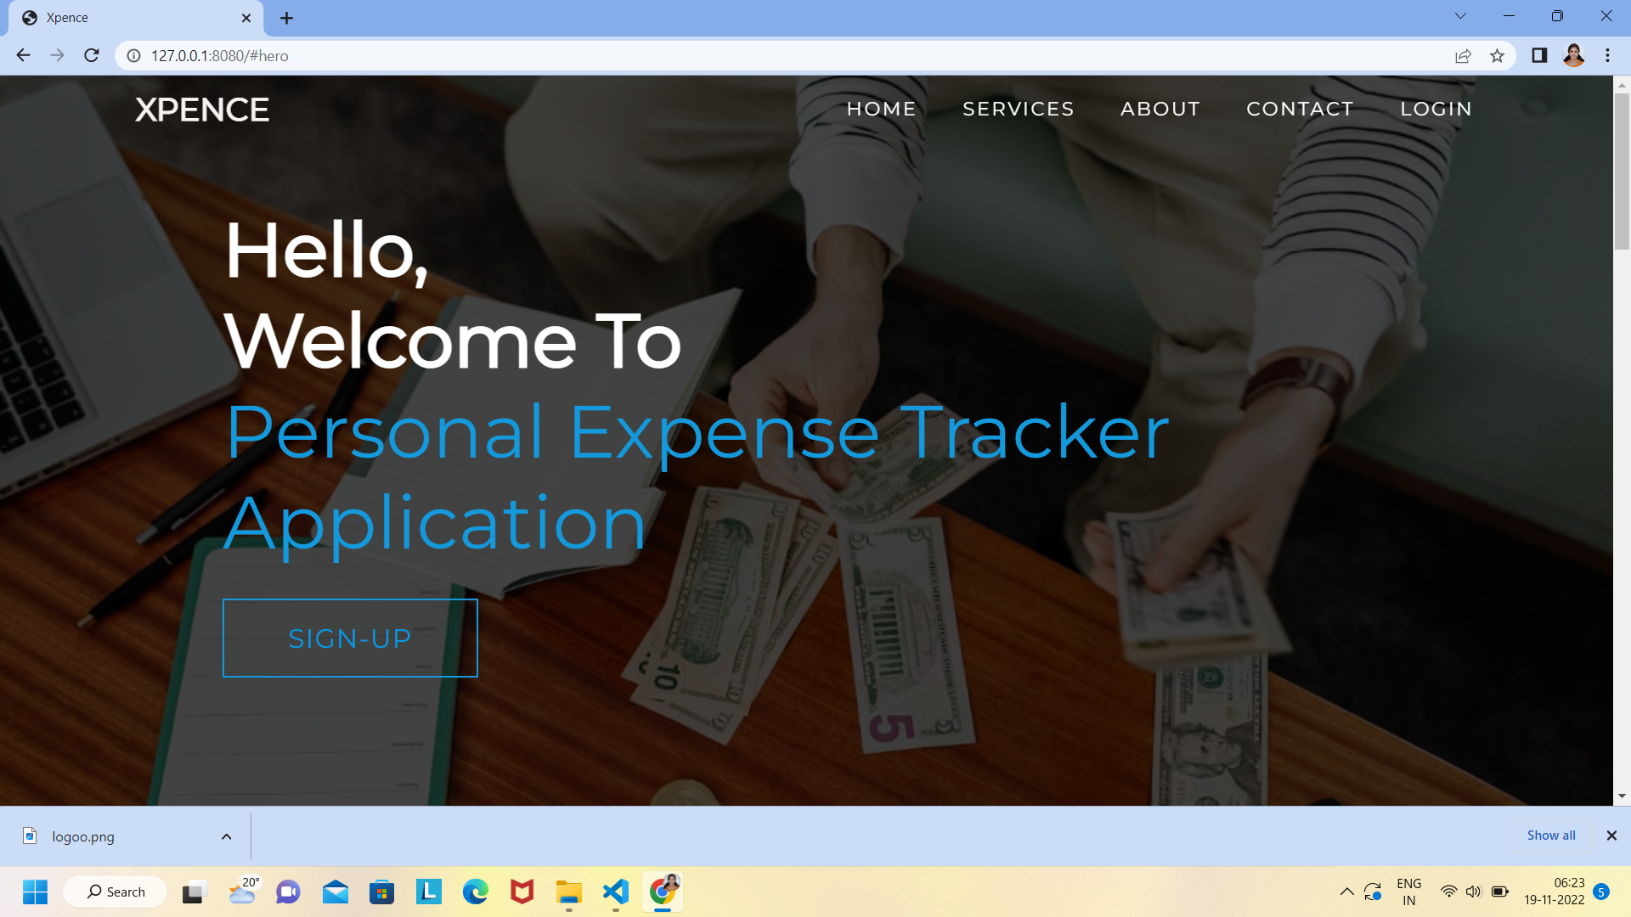

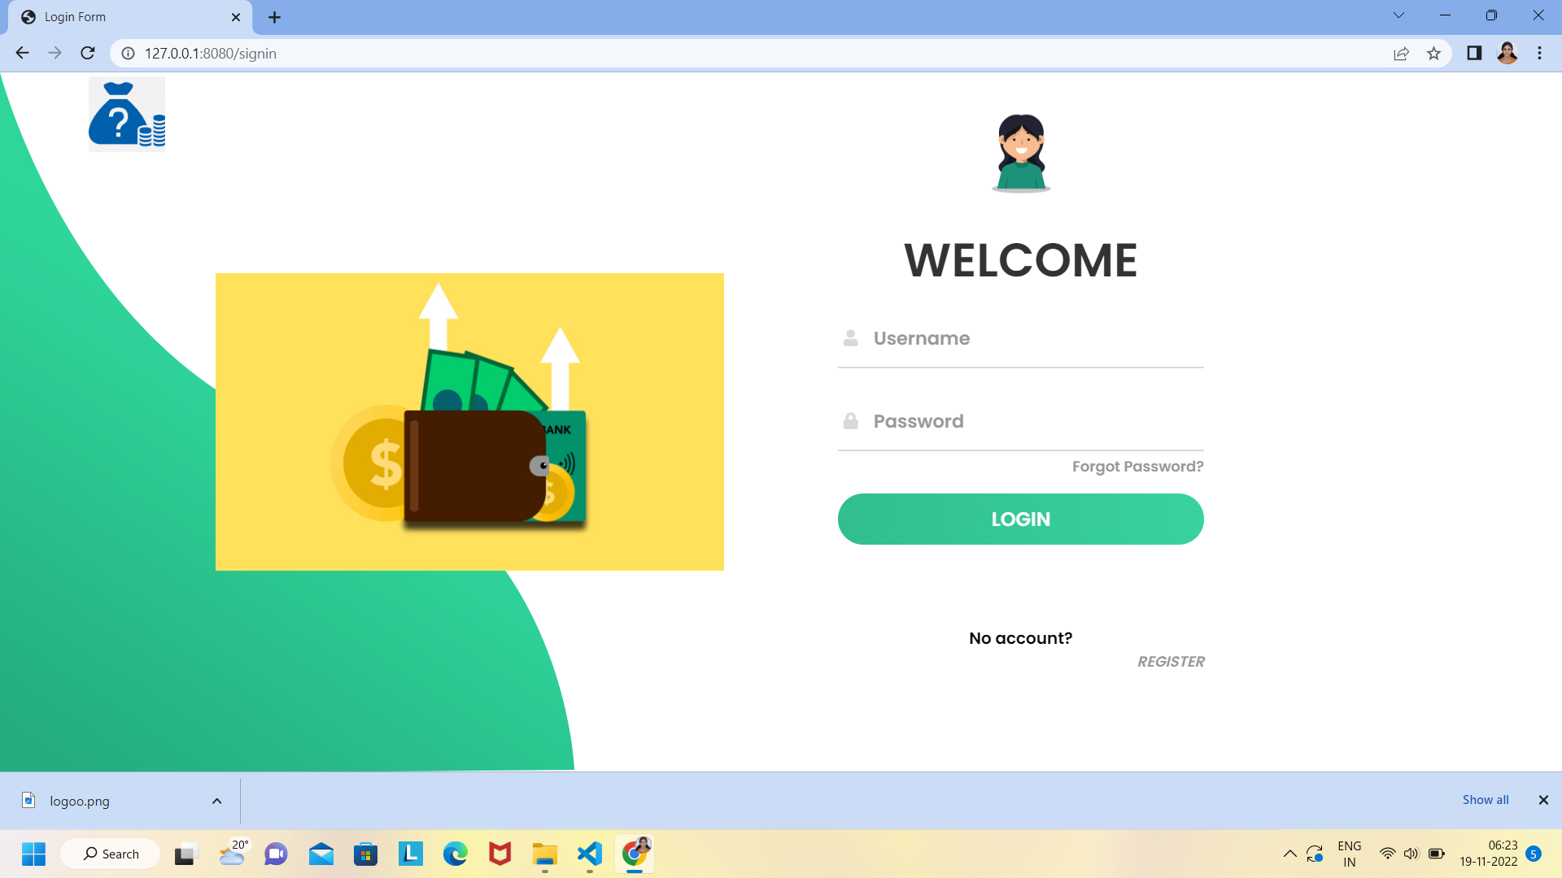

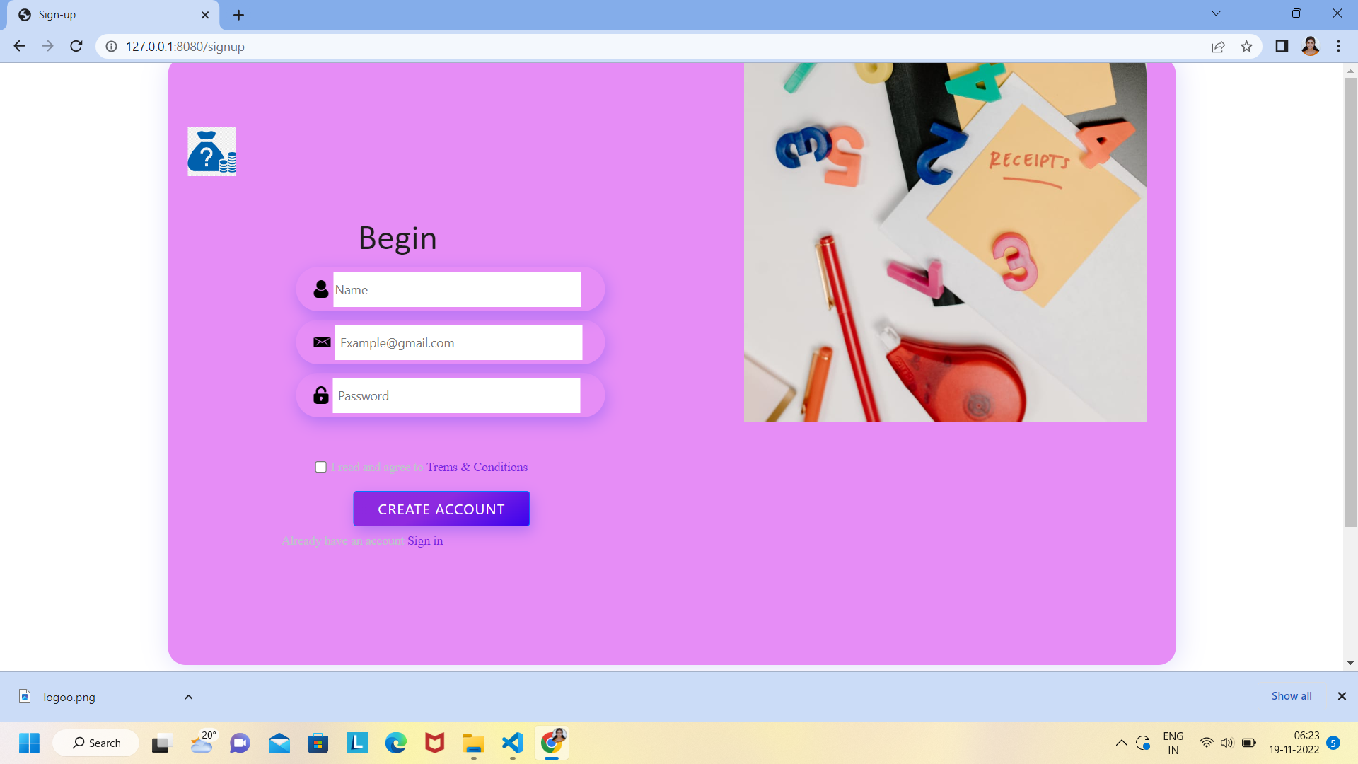

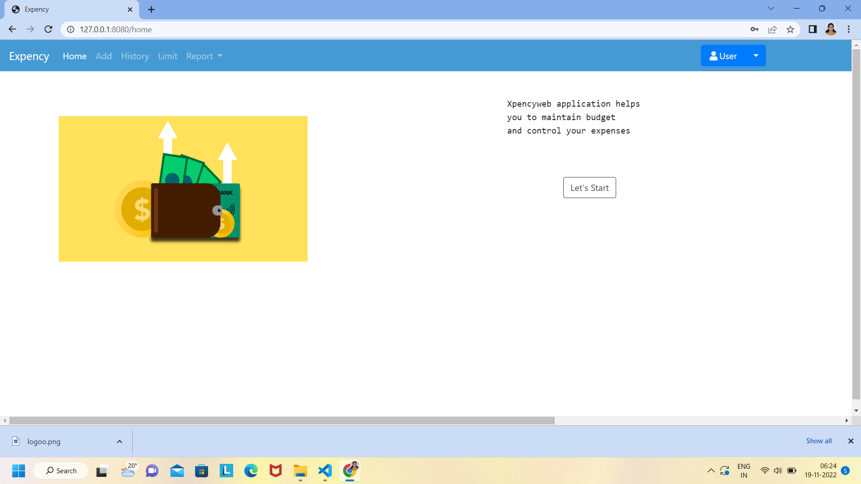

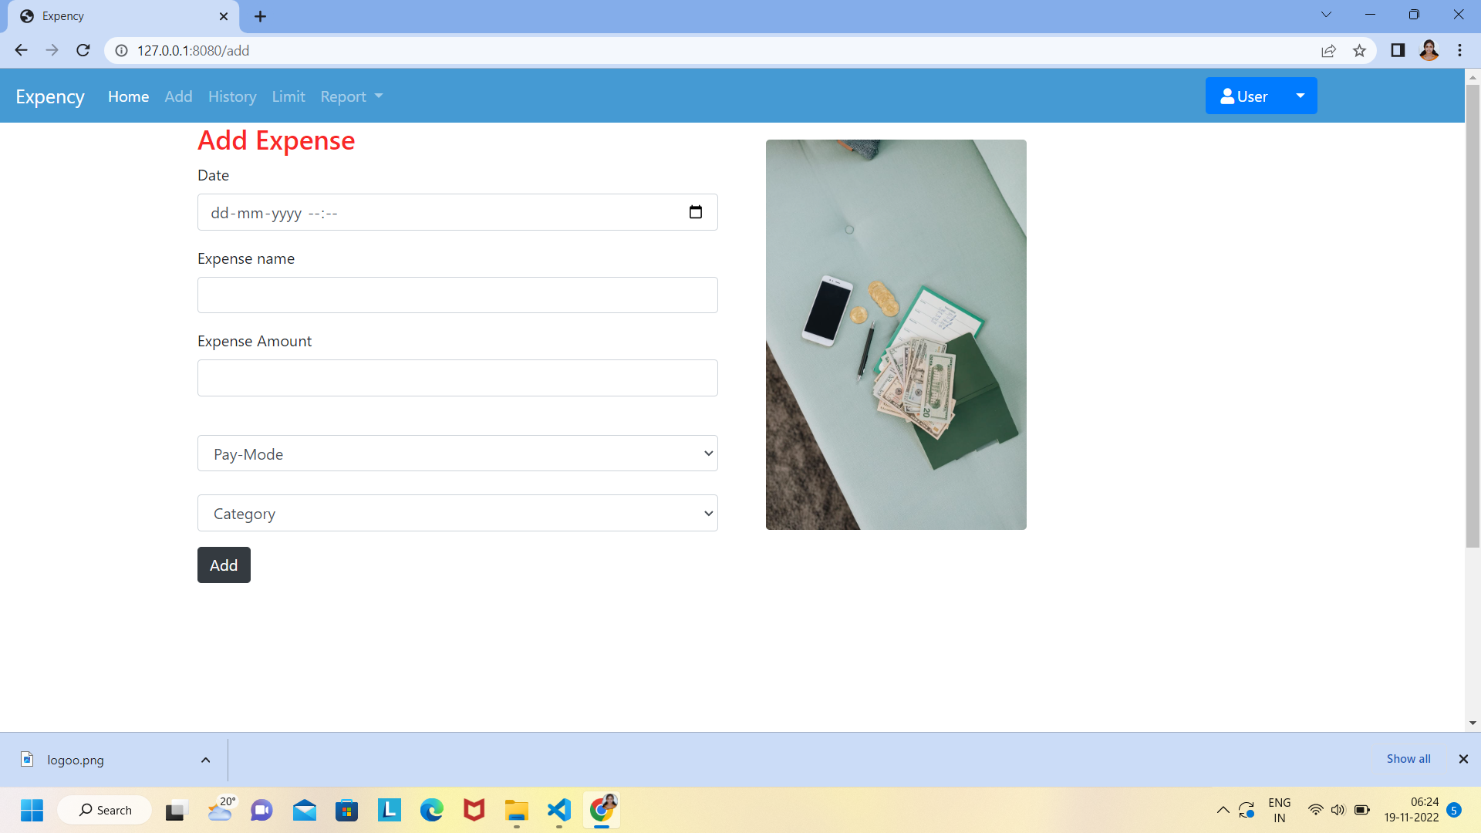

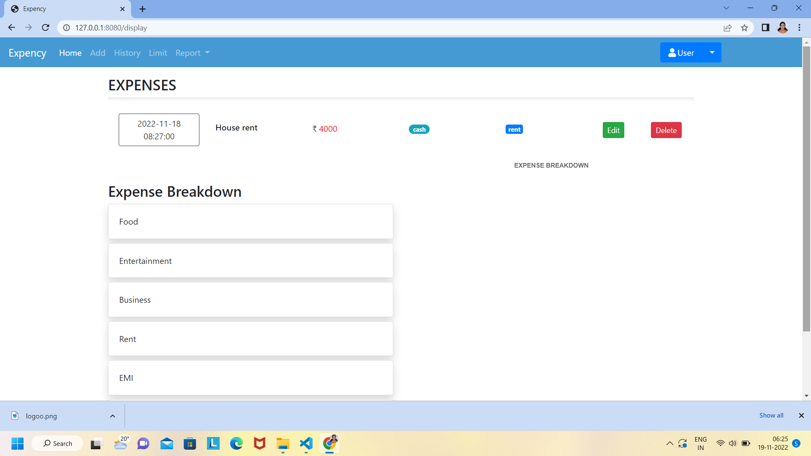

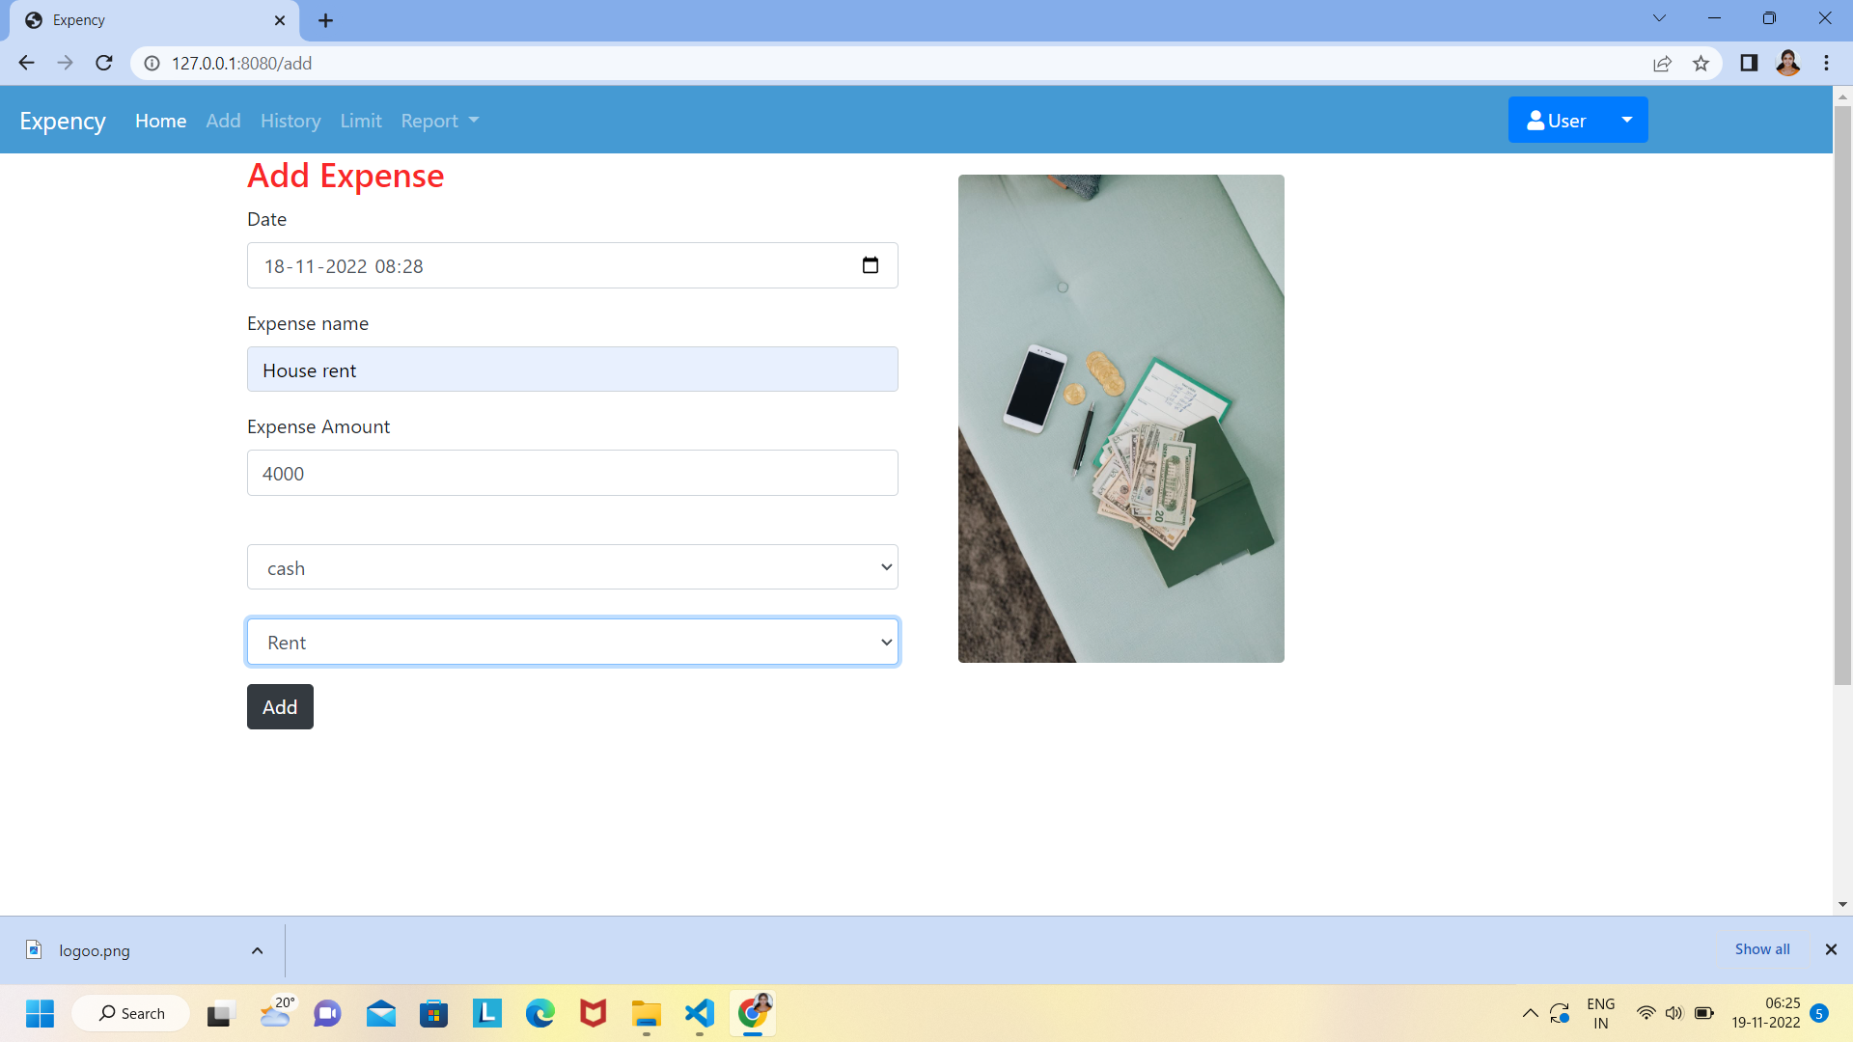

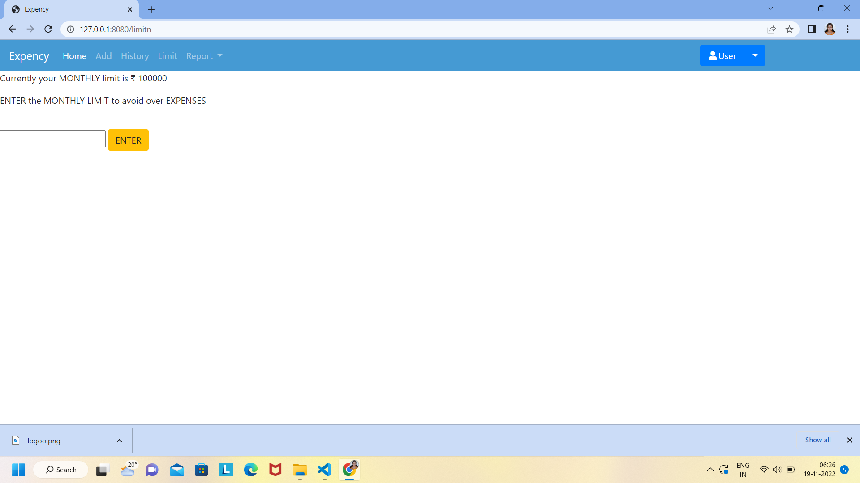



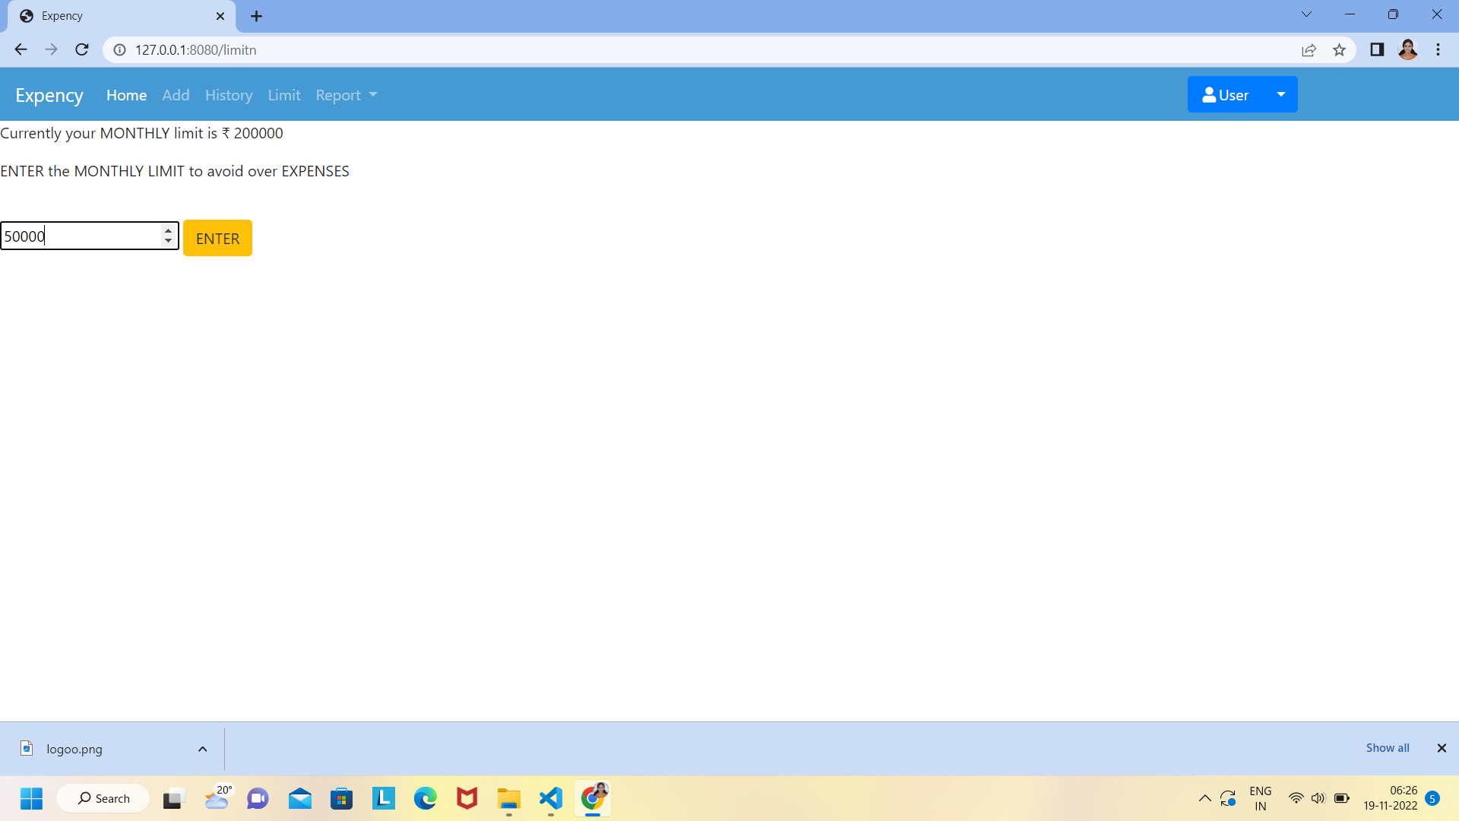

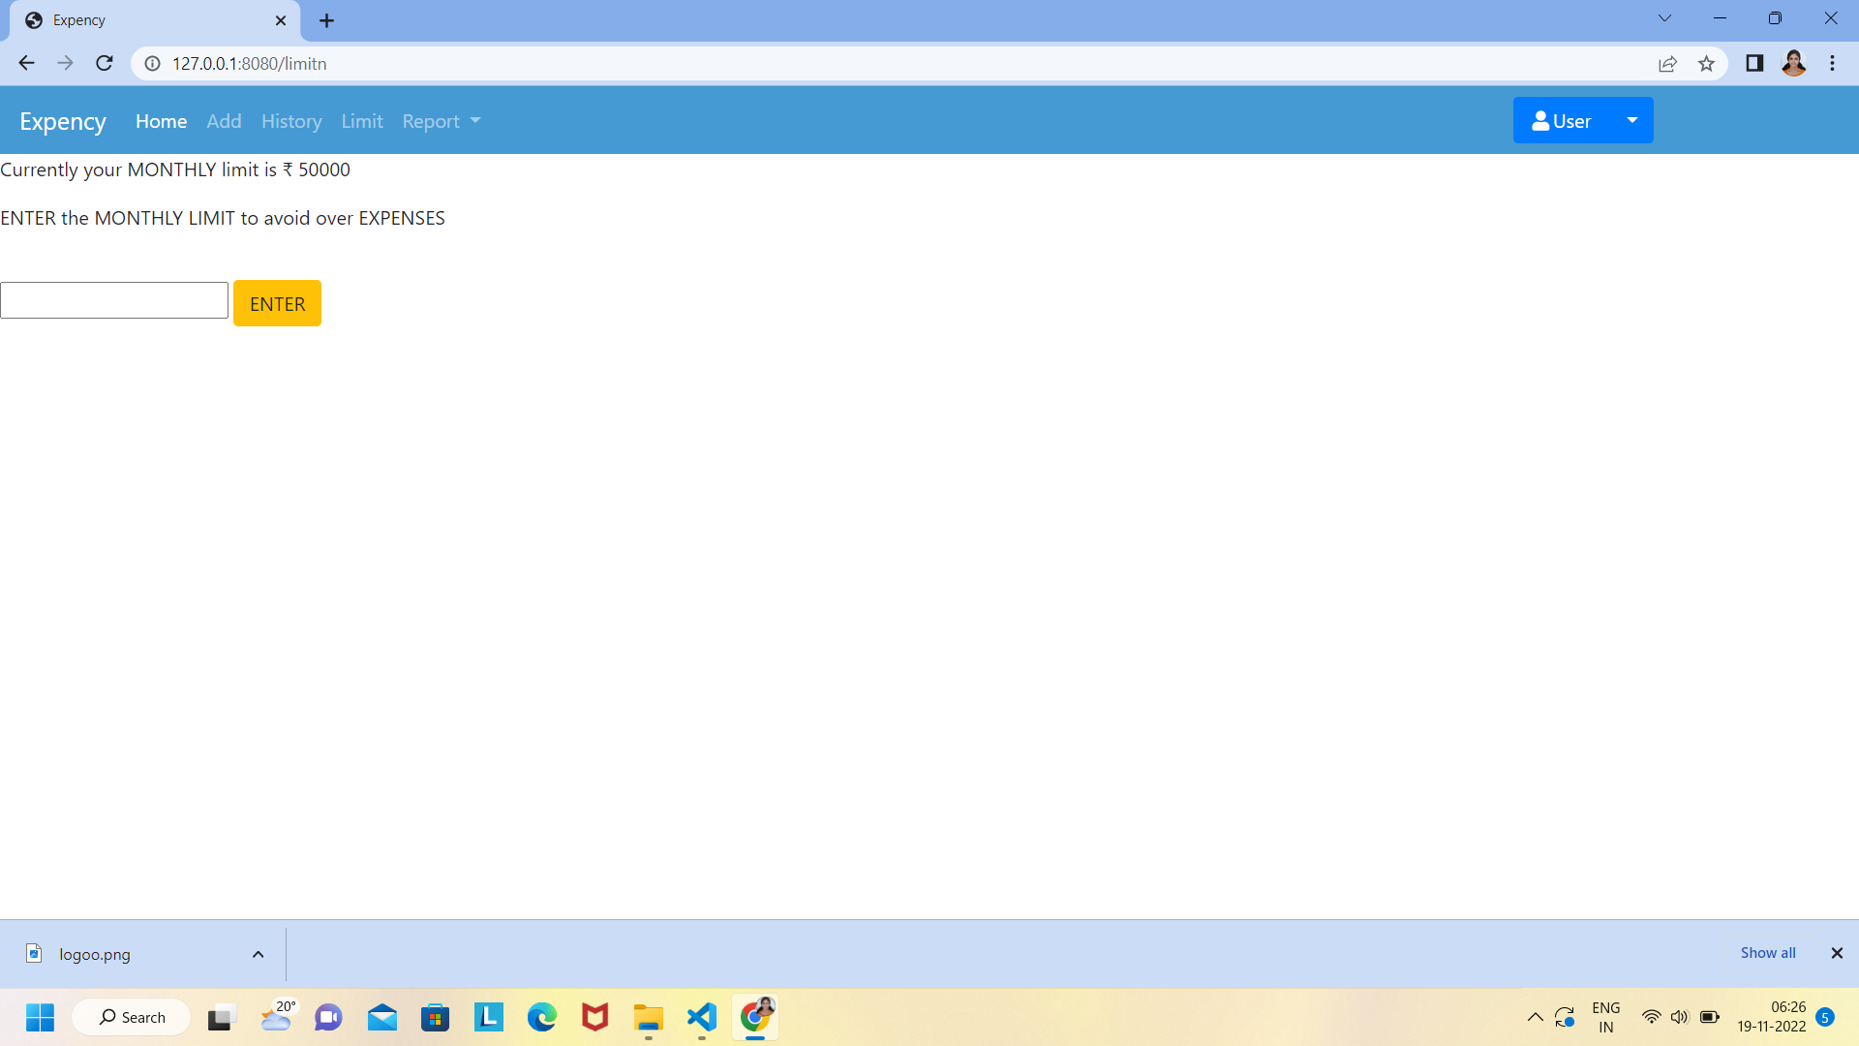

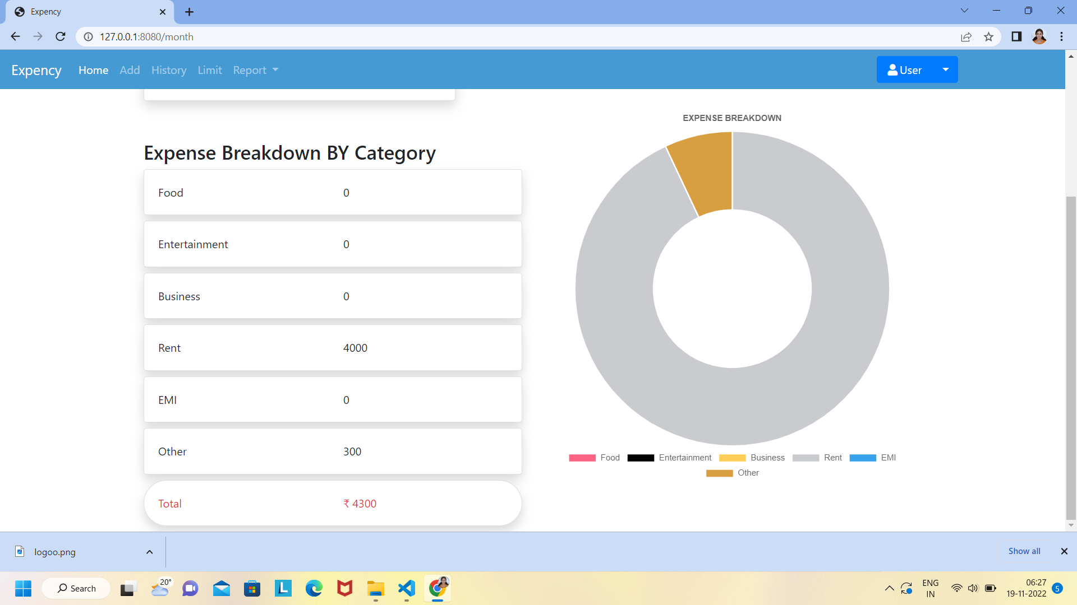

**8.RESULTS**

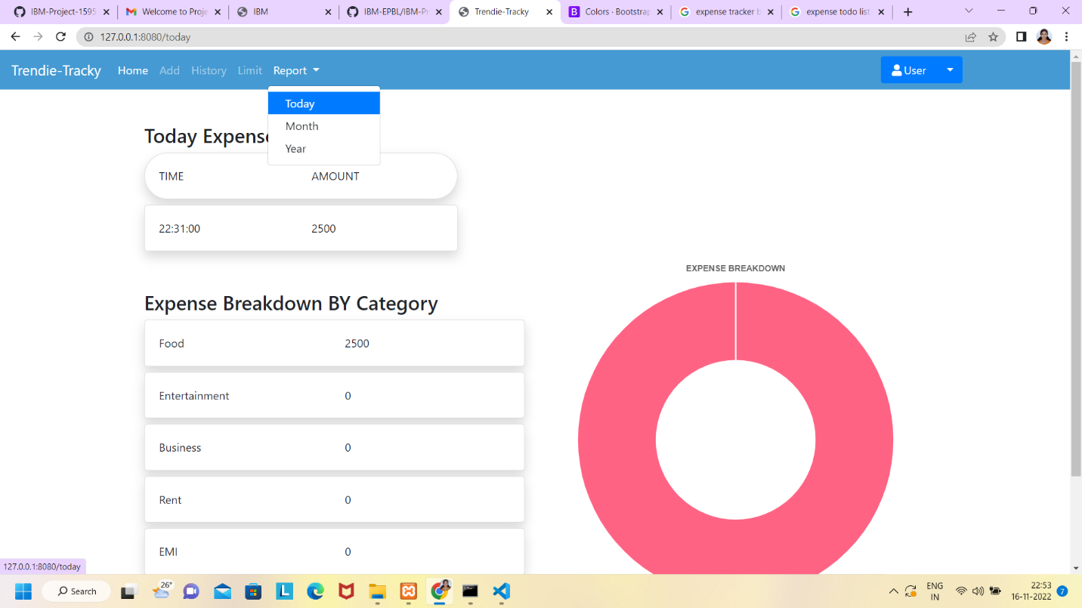

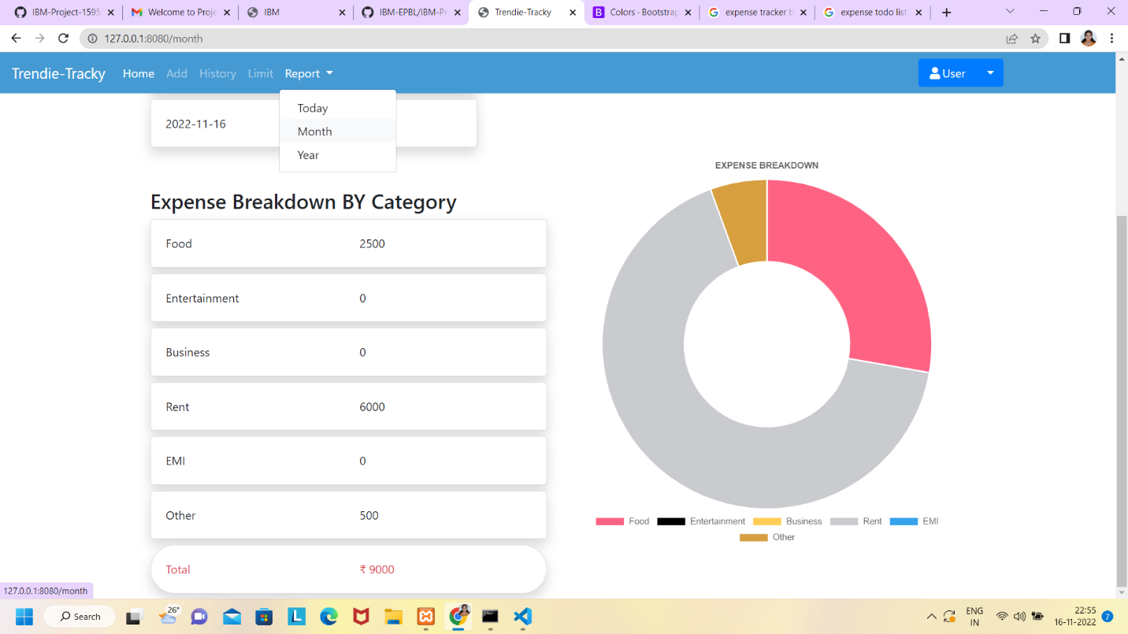

**9. ADVANTAGES & DISADVANTAGES**

**ADVANTAGES:**

* User friendly interface.
* User can insert different budget for different time frame.
* Has prediction whether user will overspend based on previous spending.
* User can insert different budget for different time frame.
* User can put different values on each type of purchase.
* Has estimation on the amount for user to use to stick to budget

**DISADVANTAGES:**

* Complex interface.
* No prediction if user might overspend.
* Cannot manage categories properly.
* Initial balance, income and expenses are not separately categorized by cash and bank transfer.

**10.CONCLUSION**

Tracking the daily expenses can not only help in saving money but also help in setting financial goals for the future. If we know where our money is being spent every day, it is easy to set some cutbacks and such to help reduce expenditure. This project is developed to work more efficiently in comparison to other trackers and avoid manual calculation. It is developed to be efficient and look attractive at the same time.

Tracking your expenses daily can not only save your amount, but it can also assist you set financial goals for the longer term. If you know exactly where your amount goes every month, you will easily see where some cutbacks and compromises can be made. The project that we have developed is more efficient than the other income and expense trackers. The project successfully avoids the manual calculation which is performed usually in the absence of an expense tracker. The modules are developed efficiently and also in an attractive manner. The application will eliminate sticky notes, spreadsheets, and ledgers that cause confusion, data in consistency problems while recording and splitting expenses. With our application users can manage their expenses more effectively and they will be better at managing the expenses.

**11.FUTURE SCOPE**

In future the Expense Tracker can be enhanced by adding the feature to “incorporate a shared expense group” apart from keeping a personal expense log.Provision to add different currencies will be added so that this application is not just limited to USA but also can be used worldwide and the currency converters will be designed and added in order to convert the different currency rates.

In order to make it more user friendly and less user intensive, when the user tries to add the same category or vendor to an expense/income record, a duplicate alert will be presented showing the same category/vendor which the user entered previously for some expense/income and then he can tap on it and the entries will be automatically filled for the current record.

**12) APPENDIX**

|  |
| --- |
| `  # Project : Personal Expense Tracker Application  # Team ID : PNT2022TMID48482      **Home.html**    <!DOCTYPE html>  <html lang="en">    <head>  <meta charset="UTF-8">  <meta name="viewport" content="width=device-width, initial-scale=1.0">      <link rel="stylesheet" href="..\static\css\home.css">  <title>Trendie-Tracky</title>  </head>    <body>  <!-- Header -->  <section id="header">  <div class="header container">  <div class="nav-bar">  <div class="brand">  <a href="#hero">  </a>  </div>  <div class="nav-list">  <div class="hamburger">  <div class="bar"></div>  </div>  <ul>  <li><a href="#hero" data-after="Home">Home</a></li>  <li><a href="#services" data-after="Service">Services</a></li>    <li><a href="#about" data-after="About">About</a></li>  <li><a href="#contact" data-after="Contact">Contact</a></li>  <LI><a href="/signin" data-after="Login">Login</a></LI>  </ul>  </div>  </div>  </div>  </section>  <!-- End Header -->      <!-- Hero Section -->  <section id="hero">  <div class="hero container">  <div>  <h1>Hello, <span></span></h1>  <h1>Welcome To <span></span></h1>  <h1>Personal Expense Tracker Application <span></span></h1>  <a href="/signup" type="button" class="cta">Sign-up</a>  </div>  </div>  </section>  <!-- End Hero Section -->    <!-- Service Section -->  <section id="services">  <div class="services container">  <div class="service-top">  <h1 class="section-title">Serv<span>i</span>ces</h1>  <p>Trandie-Tracky provides a many services to deal with your daily financial expenses. Together can Stop the unnecessay spendings </p>  </div>  <div class="service-bottom">  <div class="service-item">  <div class="icon"><img src="https://img.icons8.com/bubbles/100/000000/services.png" /></div>  <h2>Personal Expenses</h2>  <p>Budgeting is more than paying bills and setting aside savings.it's about creating a money plan for the life you want</p>  </div>  <div class="service-item">  <div class="icon"><img src="https://img.icons8.com/bubbles/100/000000/services.png" /></div>  <h2>Investments</h2>  <p>Follow your investments and bring your portfolio into focus with support for stocks,bonds,CDs,mutual funds and more</p>  </div>  <div class="service-item">  <div class="icon"><img src="https://img.icons8.com/bubbles/100/000000/services.png" /></div>  <h2>Online Banking</h2>  <p>MyBudget application can automatically download transactions and send payments online from many financial institutions</p>  </div>  <div class="service-item">  <div class="icon"><img src="https://img.icons8.com/bubbles/100/000000/services.png" /></div>  <h2>Financial Life</h2>  <p>Get your Complete financial picture at a glance. With MyBudget application you can view your all the financial activities  </p>  </div>  </div>  </div>  </section>  <!-- End Service Section -->    <!-- About Section -->  <section id="about">  <div class="about container">  <div class="col-left">  <div class="about-img">  <img src="..\static\images\img_2.jpg" alt="img">  <div><h2>Chettinad College of Engineering <br> and Technology </h2></div>  </div>  </div>    <div class="col-right">  <h1 class="section-title">About <span>Us</span></h1>  <h2>Financial Solution</h2>  <p>Trendie-Tracky is an expenses tracking application. It provides many services to the customers to meet their needs whatever their money goals,there is a udgeting application help to reach them.You can Contact our service center for further information and also follow our social media for update on new services </p>  <a href="#footer" class="cta">Follow Us</a>    </div>  </div>  </section>  <!-- End About Section -->    <!-- Contact Section -->  <section id="contact">  <div class="contact container">  <div>  <h1 class="section-title">Contact <span>info</span></h1>  </div>  <div class="contact-items">  <div class="contact-item">  <div class="icon"><img src="https://img.icons8.com/bubbles/100/000000/phone.png" /></div>  <div class="contact-info">  <h1>Phone</h1>  <h2>+91 9645  240824</h2>  </div>  </div>  <div class="contact-item">  <div class="icon"><img src="https://img.icons8.com/bubbles/100/000000/new-post.png" /></div>  <div class="contact-info">  <h1>Email</h1>  <h2>suryacse751@gmail.com  prabakaran@gmail.com    </h2>  </div>  </div>  <div class="contact-item">  <div class="icon"><img src="https://img.icons8.com/bubbles/100/000000/map-marker.png" /></div>  <div class="contact-info">  <h1>Address</h1>  <h2>Chettinad College of Engineering and Technology, Tamilnadu.</h2>  </div>  </div>  </div>  </div>  </section>  <!-- End Contact Section -->    <!-- Footer -->  <section id="footer">  <div class="footer container">  <div class="brand">  </div>  <h2>Your Complete Financial Solution</h2>  <div class="social-icon">  <div class="social-item">  <a href="#"><img src="https://img.icons8.com/bubbles/100/000000/facebook-new.png" /></a>  </div>  <div class="social-item">  <a href="#"><img src="https://img.icons8.com/bubbles/100/000000/instagram-new.png" /></a>  </div>  <div class="social-item">  <a href="#"><img src="https://img.icons8.com/bubbles/100/000000/behance.png" /></a>  </div>  </div>  <p>Copyright Â© 2022 Chettinad. All rights reserved</p>  </div>  </section>  <!-- End Footer -->  <script src="..\static\js\home.js"></script>  </body>    </html>    **Login.html**    <!DOCTYPE html>  <html lang="en">    <head>  <meta charset="UTF-8">  <meta name="viewport" content="width=device-width, initial-scale=1.0">      <link rel="stylesheet" href="..\static\css\home.css">  <title>Trendie-Tracky</title>  </head>    <body>  <!-- Header -->  <section id="header">  <div class="header container">  <div class="nav-bar">  <div class="brand">  <a href="#hero">  </a>  </div>  <div class="nav-list">  <div class="hamburger">  <div class="bar"></div>  </div>  <ul>  <li><a href="#hero" data-after="Home">Home</a></li>  <li><a href="#services" data-after="Service">Services</a></li>    <li><a href="#about" data-after="About">About</a></li>  <li><a href="#contact" data-after="Contact">Contact</a></li>  <LI><a href="/signin" data-after="Login">Login</a></LI>  </ul>  </div>  </div>  </div>  </section>  <!-- End Header -->      <!-- Hero Section -->  <section id="hero">  <div class="hero container">  <div>  <h1>Hello, <span></span></h1>  <h1>Welcome To <span></span></h1>  <h1>Personal Expense Tracker Application <span></span></h1>  <a href="/signup" type="button" class="cta">Sign-up</a>  </div>  </div>  </section>  <!-- End Hero Section -->    <!-- Service Section -->  <section id="services">  <div class="services container">  <div class="service-top">  <h1 class="section-title">Serv<span>i</span>ces</h1>  <p>Trandie-Tracky provides a many services to deal with your daily financial expenses. Together can Stop the unnecessay spendings </p>  </div>  <div class="service-bottom">  <div class="service-item">  <div class="icon"><img src="https://img.icons8.com/bubbles/100/000000/services.png" /></div>  <h2>Personal Expenses</h2>  <p>Budgeting is more than paying bills and setting aside savings.it's about creating a money plan for the life you want</p>  </div>  <div class="service-item">  <div class="icon"><img src="https://img.icons8.com/bubbles/100/000000/services.png" /></div>  <h2>Investments</h2>  <p>Follow your investments and bring your portfolio into focus with support for stocks,bonds,CDs,mutual funds and more</p>  </div>  <div class="service-item">  <div class="icon"><img src="https://img.icons8.com/bubbles/100/000000/services.png" /></div>  <h2>Online Banking</h2>  <p>MyBudget application can automatically download transactions and send payments online from many financial institutions</p>  </div>  <div class="service-item">  <div class="icon"><img src="https://img.icons8.com/bubbles/100/000000/services.png" /></div>  <h2>Financial Life</h2>  <p>Get your Complete financial picture at a glance. With MyBudget application you can view your all the financial activities  </p>  </div>  </div>  </div>  </section>  <!-- End Service Section -->    <!-- About Section -->  <section id="about">  <div class="about container">  <div class="col-left">  <div class="about-img">  <img src="..\static\images\img_2.jpg" alt="img">  <div><h2>Chettinad College of Engineering <br> and Technology </h2></div>  </div>  </div>    <div class="col-right">  <h1 class="section-title">About <span>Us</span></h1>  <h2>Financial Solution</h2>  <p>Trendie-Tracky is an expenses tracking application. It provides many services to the customers to meet their needs whatever their money goals,there is a udgeting application help to reach them.You can Contact our service center for further information and also follow our social media for update on new services </p>  <a href="#footer" class="cta">Follow Us</a>    </div>  </div>  </section>  <!-- End About Section -->    <!-- Contact Section -->  <section id="contact">  <div class="contact container">  <div>  <h1 class="section-title">Contact <span>info</span></h1>  </div>  <div class="contact-items">  <div class="contact-item">  <div class="icon"><img src="https://img.icons8.com/bubbles/100/000000/phone.png" /></div>  <div class="contact-info">  <h1>Phone</h1>  <h2>+91 9645  240824</h2>  </div>  </div>  <div class="contact-item">  <div class="icon"><img src="https://img.icons8.com/bubbles/100/000000/new-post.png" /></div>  <div class="contact-info">  <h1>Email</h1>  <h2>darshanadachu@gmail.com  radhika@gmail.com  rajeshwarisomasundaram@gmail.com  shreeolimathi13@gmail.com  </h2>  </div>  </div>  <div class="contact-item">  <div class="icon"><img src="https://img.icons8.com/bubbles/100/000000/map-marker.png" /></div>  <div class="contact-info">  <h1>Address</h1>  <h2>Chettinad College of Engineering and Technology, Tamilnadu.</h2>  </div>  </div>  </div>  </div>  </section>  <!-- End Contact Section -->    <!-- Footer -->  <section id="footer">  <div class="footer container">  <!DOCTYPE html>  <html>  <head>  <title>Login Form</title>  <link rel="stylesheet" type="text/css" href="..\static\css\login.css">  <link href="https://fonts.googleapis.com/css?family=Poppins:600&display=swap" rel="stylesheet">  <script src="https://kit.fontawesome.com/a81368914c.js"></script>  <meta name="viewport" content="width=device-width, initial-scale=1">  </head>  <body >  <img class="wave" src="..\static\images\wave.png">  <div class="container">    <div class="img">  <div id="png"><a href="/" title="HOME"><img style="width:75px; height:75px ; " src="..\static\images\home-icon.jpg"></a></div>  <img src="..\static\images\dia.jpg">  </div>      <div class="login-content">    <form action='/login' method="POST">  <div class="msg">{{ msg }}</div>  <img src="..\static\images\avatar.jpg">  <h2 class="title">Welcome</h2>  <div class="input-div one">  <div class="i">  <i class="fas fa-user"></i>  </div>  <div class="div">  <h5>Username</h5>  <input type="text" name="username" class="input" required>  </div>  </div>  <div class="input-div pass">  <div class="i">  <i class="fas fa-lock"></i>  </div>  <div class="div">  <h5>Password</h5>  <input type="password" name="password" class="input" required>  </div>  </div>  <a href="#">Forgot Password?</a>  <input type="submit" class="btn" value="Login">    <div>  <ul>      </ul>    </div>  </form>    </div>    </div>    <script type="text/javascript" src="..\static\js\login.js"></script>  </body>  </html>    **Home.css**    @import 'https://fonts.googleapis.com/css?family=Montserrat:300, 400, 700&display=swap';  * {  padding: 0;  margin: 0;  box-sizing: border-box;  }  html {  font-size: 10px;  font-family: 'Montserrat', sans-serif;  scroll-behavior: smooth;  }  a {  text-decoration: none;  }  .container {  min-height: 100vh;  width: 100%;  display: flex;  align-items: center;  justify-content: center;  }  img {  height: 100%;  width: 100%;  object-fit: cover;  }  p {  color: black;  font-size: 1.4rem;  margin-top: 5px;  line-height: 2.5rem;  font-weight: 300;  letter-spacing: 0.05rem;  }  .section-title {  font-size: 4rem;  font-weight: 300;  color: black;  margin-bottom: 10px;  text-transform: uppercase;  letter-spacing: 0.2rem;  text-align: center;  }  .section-title span {  color: rgb(141, 209, 240);  }    .cta {  display: inline-block;  padding: 10px 30px;  color: rgb(2, 153, 220);  background-color: transparent;  border: 2px solid rgb(20, 153, 220);  font-size: 2rem;  text-transform: uppercase;  letter-spacing: 0.1rem;  margin-top: 30px;  transition: 0.3s ease;  transition-property: background-color, color;  }  .cta:hover {  color: white;  background-color: rgb(20, 153, 220);  }  .brand h1 {  font-size: 3rem;  text-transform: uppercase;  color: rgb(248, 244, 244);  }  .brand h1 span {  color: rgb(20, 153, 220);  }    /* Header section */  #header {  position: fixed;  z-index: 1000;  left: 0;  top: 0;  width: 100vw;  height: auto;  }  #header .header {  min-height: 8vh;  background-color: rgba(31, 30, 30, 0.24);  transition: 0.3s ease background-color;  }  #header .nav-bar {  display: flex;  align-items: center;  justify-content: space-between;  width: 100%;  height: 100%;  max-width: 1300px;  padding: 0 10px;  }  #header .nav-list ul {  list-style: none;  position: absolute;  background-color: rgb(31, 30, 30);  width: 100vw;  height: 100vh;  left: 100%;  top: 0;  display: flex;  flex-direction: column;  justify-content: center;  align-items: center;  z-index: 1;  overflow-x: hidden;  transition: 0.5s ease left;  }  #header .nav-list ul.active {  left: 0%;  }  #header .nav-list ul a {  font-size: 2.5rem;  font-weight: 500;  letter-spacing: 0.2rem;  text-decoration: none;  color: white;  text-transform: uppercase;  padding: 20px;  display: block;  }  #header .nav-list ul a::after {  content: attr(data-after);  position: absolute;  top: 50%;  left: 50%;  transform: translate(-50%, -50%) scale(0);  color: rgba(240, 248, 255, 0.021);  font-size: 13rem;  letter-spacing: 50px;  z-index: -1;  transition: 0.3s ease letter-spacing;  }  #header .nav-list ul li:hover a::after {  transform: translate(-50%, -50%) scale(1);  letter-spacing: initial;  }  #header .nav-list ul li:hover a {  color: rgb(20, 153, 220);  }  #header .hamburger {  height: 60px;  width: 60px;  display: inline-block;  border: 3px solid white;  border-radius: 50%;  position: relative;  display: flex;  align-items: center;  justify-content: center;  z-index: 100;  cursor: pointer;  transform: scale(0.8);  margin-right: 20px;  }  #header .hamburger:after {  position: absolute;  content: '';  height: 100%;  width: 100%;  border-radius: 50%;  border: 3px solid white;  animation: hamburger_puls 1s ease infinite;  }  #header .hamburger .bar {  height: 2px;  width: 30px;  position: relative;  background-color: white;  z-index: -1;  }  #header .hamburger .bar::after,  #header .hamburger .bar::before {  content: '';  position: absolute;  height: 100%;  width: 100%;  left: 0;  background-color: white;  transition: 0.3s ease;  transition-property: top, bottom;  }  #header .hamburger .bar::after {  top: 8px;  }  #header .hamburger .bar::before {  bottom: 8px;  }  #header .hamburger.active .bar::before {  bottom: 0;  }  #header .hamburger.active .bar::after {  top: 0;  }  /* End Header section */    /* Hero Section */  #hero {  background-image: url(../images/img-1.jpg);  background-size: cover;  background-position: top center;  position: relative;  z-index: 1;  }  #hero::after {  content: '';  position: absolute;  left: 0;  top: 0;  height: 100%;  width: 100%;  background-color: black;  opacity: 0.7;  z-index: -1;  }  #hero .hero {  max-width: 1200px;  margin: 0 auto;  padding: 0 50px;  justify-content: flex-start;  }  #hero h1 {  display: block;  width: fit-content;  font-size: 4rem;  position: relative;  color: transparent;  animation: text_reveal 0.5s ease forwards;  animation-delay: 1s;  }  #hero h1:nth-child(1) {  animation-delay: 1s;  }  #hero h1:nth-child(2) {  animation-delay: 2s;  }  #hero h1:nth-child(3) {  animation: text_reveal_name 0.5s ease forwards;  animation-delay: 3s;  }  #hero h1 span {  position: absolute;  top: 0;  left: 0;  height: 100%;  width: 0;  background-color: rgb(20, 153, 220);  animation: text_reveal_box 1s ease;  animation-delay: 0.5s;  }  #hero h1:nth-child(1) span {  animation-delay: 0.5s;  }  #hero h1:nth-child(2) span {  animation-delay: 1.5s;  }  #hero h1:nth-child(3) span {  animation-delay: 2.5s;  }  **app.py**  #TEAM ID: PNT2022TMID48484  from flask import Flask, render_template, request, redirect, session  # from flask_mysqldb import MySQL  # import MySQLdb.cursors  import re  from flask_db2 import DB2  import ibm_db  import ibm_db_dbi  from sendemail import sendgridmail,sendmail  # from gevent.pywsgi import WSGIServer  import os    app = Flask(__name__)  app.secret_key = 'a'    # app.config['MYSQL_HOST'] = 'remotemysql.com'  # app.config['MYSQL_USER'] = 'D2DxDUPBii'  # app.config['MYSQL_PASSWORD'] = 'r8XBO4GsMz'  # app.config['MYSQL_DB'] = 'D2DxDUPBii'  """  dsn_hostname = "3883e7e4-18f5-4afe-be8c-fa31c41761d2.bs2io90l08kqb1od8lcg.databases.appdomain.cloud"  dsn_uid = "sbb93800"  dsn_pwd = "wobsVLm6ccFxcNLe"  dsn_driver = "{IBM DB2 ODBC DRIVER}"  dsn_database = "bludb"  dsn_port = "31498"  dsn_protocol = "tcpip"  dsn = (  "DRIVER={0};"  "DATABASE={1};"  "HOSTNAME={2};"  "PORT={3};"  "PROTOCOL={4};"  "UID={5};"  "PWD={6};"  ).format(dsn_driver, dsn_database, dsn_hostname, dsn_port, dsn_protocol, dsn_uid, dsn_pwd)  """  # app.config['DB2_DRIVER'] = '{IBM DB2 ODBC DRIVER}'  app.config['database'] = 'bludb'  app.config['hostname'] = '3883e7e4-18f5-4afe-be8c-fa31c41761d2.bs2io90l08kqb1od8lcg.databases.appdomain.cloud'  app.config['port'] = '31498'  app.config['protocol'] = 'tcpip'  app.config['uid'] = 'sbb93800'  app.config['pwd'] = 'wobsVLm6ccFxcNLe'  app.config['security'] = 'SSL'  try:  mysql = DB2(app)  conn_str='database=bludb;hostname=3883e7e4-18f5-4afe-be8c-fa31c41761d2.bs2io90l08kqb1od8lcg.databases.appdomain.cloud;port=31498;protocol=tcpip;\  uid=sbb93800;pwd=wobsVLm6ccFxcNLe;security=SSL'  ibm_db_conn = ibm_db.connect(conn_str,'','')    print("Database connected without any error !!")  except:  print("IBM DB Connection error : " + DB2.conn_errormsg())  # app.config['']  # mysql = MySQL(app)    #HOME--PAGE  @app.route("/home")  def home():  return render_template("homepage.html")  @app.route("/")  def add():  return render_template("home.html")    #SIGN--UP--OR--REGISTER    @app.route("/signup")  def signup():  return render_template("signup.html")    @app.route('/register', methods =['GET', 'POST'])  def register():  msg = ''  print("Break point1")  if request.method == 'POST' :  username = request.form['username']  email = request.form['email']  password = request.form['password']  print("Break point2" + "name: " + username + "------" + email + "------" + password)  try:  print("Break point3")  connectionID = ibm_db_dbi.connect(conn_str, '', '')  cursor = connectionID.cursor()  print("Break point4")  except:  print("No connection Established")  # cursor = mysql.connection.cursor()  # with app.app_context():  # print("Break point3")  # cursor = ibm_db_conn.cursor()  # print("Break point4")    print("Break point5")  sql = "SELECT * FROM register WHERE username = ?"  stmt = ibm_db.prepare(ibm_db_conn, sql)  ibm_db.bind_param(stmt, 1, username)  ibm_db.execute(stmt)  result = ibm_db.execute(stmt)  print(result)  account = ibm_db.fetch_row(stmt)  print(account)  param = "SELECT * FROM register WHERE username = " + "\'" + username + "\'"  res = ibm_db.exec_immediate(ibm_db_conn, param)  print("---- ")  dictionary = ibm_db.fetch_assoc(res)  while dictionary != False:  print("The ID is : ", dictionary["USERNAME"])  dictionary = ibm_db.fetch_assoc(res)  # dictionary = ibm_db.fetch_assoc(result)  # cursor.execute(stmt)  # account = cursor.fetchone()  # print(account)  # while ibm_db.fetch_row(result) != False:  # # account = ibm_db.result(stmt)  # print(ibm_db.result(result, "username"))  # print(dictionary["username"])  **GitHub Link:**    **https://github.com/IBM-EPBL/IBM-Project-20086-1659712352**      **Video Demo Link:** |
|  |
|  |
|  |
|  |
|  |
|  |
|  |
|  |
|  |
|  |
|  |
|  |
|  |
|  |
|  |
|  |
|  |
|  |
|  |
|  |
|  |
|  |
|  |
|  |
|  |
|  |
|  |
|  |
|  |
|  |
|  |
|  |
|  |
|  |
|  |
|  |
|  |
|  |
|  |
|  |
|  |
|  |
|  |
|  |
|  |
|  |
|  |
|  |
|  |
|  |
|  |
|  |
|  |
|  |
|  |
|  |
|  |
|  |
|  |
|  |
|  |
|  |
|  |
|  |
|  |
|  |
|  |
|  |
|  |
|  |
|  |
|  |
|  |
|  |
|  |
|  |
|  |
|  |
|  |
|  |
|  |
|  |
|  |
|  |
|  |
|  |
|  |
|  |
|  |
|  |
|  |
|  |
|  |
|  |
|  |
|  |
|  |
|  |
|  |
|  |
|  |
|  |
|  |
|  |
|  |
|  |
|  |
|  |
|  |
|  |
|  |
|  |
|  |
|  |
|  |
|  |
|  |
|  |
|  |
|  |
|  |
|  |
|  |
|  |
|  |
|  |
|  |
|  |
|  |
|  |
|  |
|  |
|  |
|  |
|  |
|  |
|  |
|  |
|  |
|  |
|  |
|  |
|  |
|  |
|  |
|  |
|  |
|  |
|  |
|  |
|  |
|  |
|  |
|  |
|  |
|  |
|  |
|  |
|  |
|  |
|  |
|  |
|  |
|  |
|  |
|  |
|  |
|  |
|  |
|  |
|  |
|  |
|  |
|  |
|  |
|  |
|  |
|  |
|  |
|  |
|  |
|  |
|  |
|  |
|  |
|  |
|  |
|  |
|  |
|  |
|  |
|  |
|  |
|  |
|  |
|  |
|  |
|  |
|  |
|  |
|  |
|  |
|  |
|  |
|  |
|  |
|  |
|  |
|  |
|  |
|  |
|  |
|  |
|  |
|  |
|  |
|  |
|  |
|  |
|  |
|  |
|  |
|  |
|  |
|  |
|  |
|  |
|  |
|  |
|  |
|  |
|  |
|  |
|  |
|  |
|  |
|  |
|  |
|  |
|  |
|  |
|  |
|  |
|  |
|  |
|  |
|  |
|  |
|  |
|  |
|  |
|  |
|  |
|  |
|  |
|  |
|  |
|  |
|  |
|  |
|  |
|  |
|  |
|  |
|  |
|  |
|  |
|  |
|  |
|  |
|  |
|  |
|  |
|  |
|  |
|  |
|  |
|  |
|  |
|  |
|  |
|  |
|  |
|  |
|  |
|  |
|  |
|  |
|  |
|  |
|  |
|  |
|  |
|  |
|  |
|  |
|  |
|  |
|  |
|  |
|  |
|  |
|  |
|  |
|  |
|  |
|  |
|  |
|  |
|  |
|  |
|  |
|  |
|  |
|  |
|  |
|  |
|  |
|  |
|  |
|  |
|  |
|  |
|  |
|  |
|  |
|  |
|  |
|  |
|  |
|  |
|  |
|  |
|  |
|  |
|  |
|  |
|  |
|  |
|  |
|  |
|  |
|  |
|  |
|  |
|  |
|  |
|  |
|  |
|  |
|  |
|  |
|  |
|  |
|  |
|  |
|  |
|  |
|  |
|  |
|  |
|  |
|  |
|  |
|  |
|  |
|  |
|  |
|  |
|  |
|  |
|  |
|  |
|  |
|  |
|  |
|  |
|  |
|  |
|  |
|  |
|  |
|  |
|  |
|  |
|  |
|  |
|  |
|  |
|  |
|  |
|  |
|  |
|  |
|  |
|  |
|  |
|  |
|  |
|  |
|  |
|  |
|  |
|  |
|  |
|  |
|  |
|  |
|  |
|  |
|  |
|  |
|  |
|  |
|  |
|  |
|  |
|  |
|  |
|  |
|  |
|  |
|  |
|  |
|  |
|  |
|  |
|  |
|  |
|  |
|  |
|  |
|  |